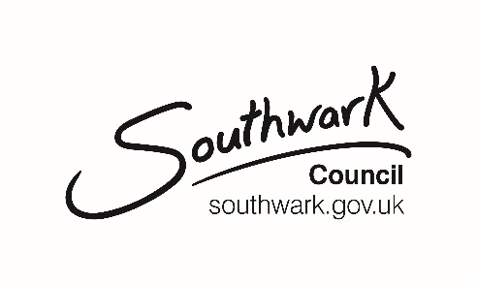
Food traders at outdoor events

All food and refreshment suppliers (all people supplying, storing and handling food) should comply with relevant health and safety legislation and in particular, food hygiene regulations issued under the Food Safety Act.

Alongside any specific information requested in your application to the event organiser, Southwark Council require the following information to be submitted for each food trader at temporary outdoor events in Southwark. Your completed form should be passed with any other application information to the organiser of the event who will in turn pass the information about all food traders at their event to the council food team.

Event details - to be completed by event organiser
Name of event | BERMONDSEY STREET FESTIVAL 2023
EventApp reference number (if known) | SWKEVE000471 - Bermondsey Street Festival
Location of event | Bermondsey Street and adjacent Parks
Date of event | 16th September 2023

Food business details – to be completed by food trader
Name of food business
Name of food business operator (owner)
Email address
Full address of food business
Name of local authority where the business is registered
Date of last food hygiene inspection
Food hygiene rating obtained
Food to be provided at the event.
describe the range or list the types of food
Is any of the food prepared before the day of the event? If yes, please give details
How many persons will be involved in the food preparation and sale at the event?
Please provide names where possible
Who will manage or supervise the food preparation and handling activities at the event?
Is there a food safety management system covering the preparation and sale of food specifically at temporary events?
Are you a member of NCASS?

